TASK 1

DATASET COLUMNS AND ROWS:

DATASET DESCRIPTION :

Total no of columns : 1778 rows × 2 columns

DATE - 2019 - 2024 data

MYWAY - - Which consist of data where the passengers board by using MYWAY card

PAPERTICKET --Which consist of data where the passengers board by using the PAPER TICKETS

Column required will for forecasting will be : APRIL 30/2024 - APRIL 1/2023

EXPLORATORY DATA ANALYSIS

DATE - Which is an column in beginning of object type converted to index by using datetime function and set_index() function

Null values : No null values present in both the columns.

* All the date are not either in ascending or descending order so sort_values() function to sort the values.
* After sorting the dataframe for forecasting should contain only 1year data..so the dataset should be reduced

After sorting and minimizing the dataset for one year The Visualization is performed :

Here The resampling method is used the see the trend as normal plotting method is not visually good.

So weekly resampling of myway and paperticket over date is performed

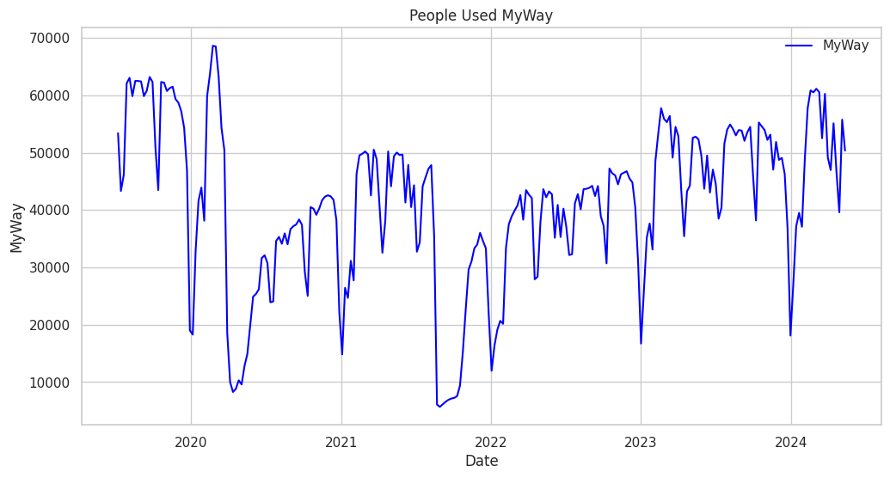

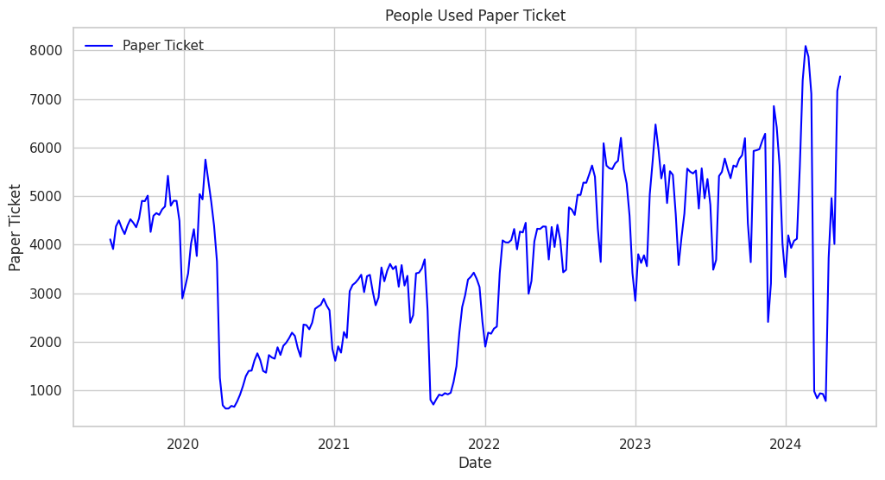

**Inference :**

* The weekly inference of myway vs paper ticket shows that people preferred myway card when compared to paper ticket.
* As myway cards are increases and decreases in regular interval of time but paper ticket shows a sudden decrease and increase of usage.

Then by performing the decomposition seasonal decompostition using additive and multiplicative the level ,trend,seasonality can be visualized and the stationarity of the data can be understood.

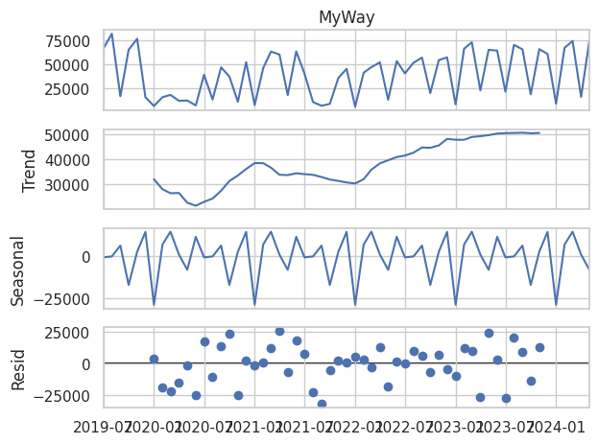

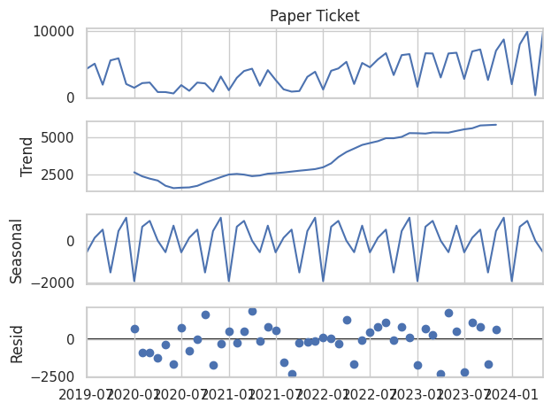

Inference:

From the above data decomposition we can infer that :

The data shows some trend and seasonality in them.Where both the Myway and the Paper Ticket method has some regular seasonal pattern and trend is also present .

Test for stationarity will be performed for Dickey Fuller Test and test for stationarity will performed.

Based on the sationarity test the mean and standard deviation is not constant

SO inorder to forecast the data Myway along with the date column ill be used.

.